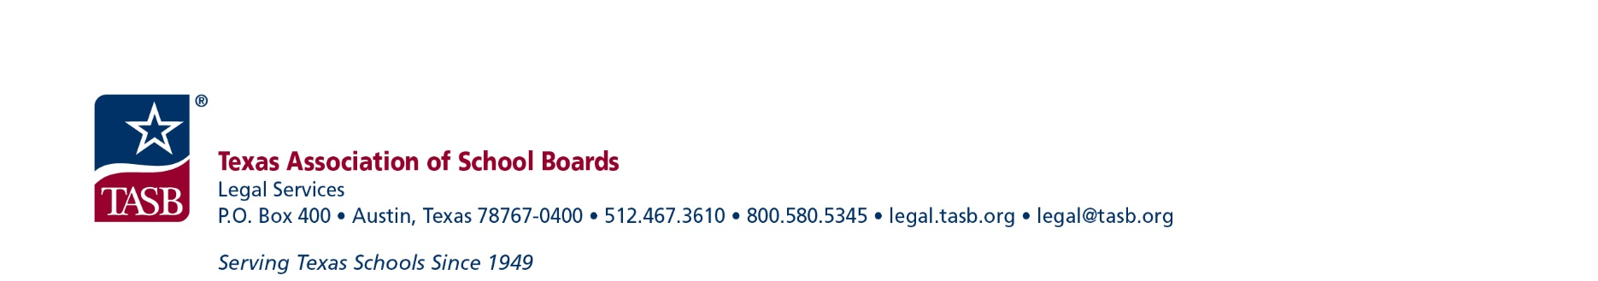
ECS Formal Complaint Form (Title IX Sexual Harassment)
Instructions for filling out this form: If you believe that you have been the victim of sexual harassment, please fill out this form, sign where indicated below, and submit it by hand delivery, electronic mail, or U.S. mail using the contact information listed for the Title IX Coordinator for students at Eastside Community School.
This formal complaint form is intended for use by the alleged victim of Title IX sexual harassment (referred to in Title IX Regulations as the “complainant”). Under Title IX and the Family Educational Rights and Privacy Act (FERPA), a parent or legal guardian may sign a complaint form and otherwise act on behalf of a minor in the formal complaint process.
If you are not filling this form out as a parent or guardian and you intend to report sexual harassment against another person in the District’s education program or activities, please report your concerns to the Eastside Community School (ECS) Title IX Coordinator so that the schol can take further action. Under federal law, only an alleged victim of sexual harassment who is currently participating or attempting to participate in the school’s education program or activity (such as an enrolled student, an employee, or an applicant for employment or admission) has the right to use the formal complaint process to initiate an investigation. ECS will process all formal complaints in accordance with FFH(LEGAL) and (LOCAL) and, as applicable, DIA(LEGAL) and (LOCAL).
Please print or type when completing this form:
Name of complainant:
Address:
Telephone number:
Email address:

Is the complainant participating in or attempting to participate in an ECS education program or activity? (See instructions.) | - Yes  - No
If you are a parent or guardian filling this form out on behalf of a minor complainant, please provide your contact information below.
Name:
Address:
Telephone number:
Email address:
You have the right to be represented by an advisor during the complaint process. The advisor may be, but does not have to be, an attorney. If you will be represented by an attorney or other advisor in presenting your complaint, please identify the person and provide the contact information below. If unknown at this time, you may provide this information at a later time.
Name:
Address:
Telephone number:
Email address:
Please list any additional individuals that you intend to bring with you to any meetings or interviews associated with this complaint and provide their contact information below. You may add additional pages or provide this information at a later time.
Name:
Address:
Telephone number:
Email address:
Please describe the facts and circumstances of the alleged sexual harassment causing this complaint. (Give specific, factual details. Attach additional sheets if necessary and indicate below how many additional pages will be attached to ensure complete receipt of your complaint.)
In a Title IX formal complaint process, the person who is alleged to have committed the sexual harassment is called the “respondent.” Please provide the name(s) of the person or people you allege to be the respondent(s) responsible for the alleged sexual harassment. If applicable, please include the person’s title or position:
When and where did the alleged sexual harassment occur? Please provide specific dates, times, and locations, if possible.
Please explain how the alleged sexual harassment has impacted you. This could include physical injuries as well as impacts on your ability to access or benefit from the school’s education program or activities.
Please provide the names and contact information of anyone who may have witnessed the alleged conduct.

If you have reported these allegations to another person, please state to whom you reported the alleged sexual harassment and provide their contact information (if known).

Title IX does not require complainants to attempt to resolve complaints of sexual harassment informally before filing a formal complaint. Nonetheless, if you have reported these allegations to a school employee, please state when, to whom, and what response you received.

Please list below any evidence that you believe is relevant to your allegations. This could include audio or visual media, physical objects, online materials, text messages, voicemail messages, screen captures, emails, or any other item you are attaching or intend to make available for the purpose of this complaint. If known, please also identify any information in the school’s possession that you believe to be relevant to your allegations and would like ECS to review (such as emails or security camera footage).

Please provide any other information that would be helpful for ECS in reviewing your allegations.
Please describe the outcome or remedy you seek for this complaint.

Please provide below your physical or digital signature.
Complainant name:
Signature of complainant:
If complainant is under 18, parent’s name:
Signature of parent:
Date of filing:

If this formal complaint is being signed by the ECS Title IX Coordinator instead of a complainant:
Title IX Coordinator Name:
Title IX Coordinator Signature:
Date of filing:

Notice to Complainant: This document is a legal record of the allegations of sexual harassment that you have reported to ECS in order to request a formal investigation. Please keep a copy of this completed form and any supporting documentation for your records. Please also review your rights and responsibilities at FFH(LEGAL), which is attached to this form and also available online at: https://pol.tasb.org/Policy/Download/247?filename=FFH(LEGAL).html&title=STUDENT%20WELFARE&subtitle=FREEDOM%20FROM%20DISCRIMINATION,%20HARASSMENT,%20AND%20RETALIATION Any questions or concerns that you may have during this process may be directed to the ECS Title IX Coordinator.
If, after reviewing your complaint form, the Title IX Coordinator finds that the allegations are not appropriate for a Title IX sexual harassment formal complaint process but should be investigated by ECS under a different policy or procedure, your formal complaint form will be forwarded to the appropriate school personnel in accordance with ECS policies. [see DIA, FFI, FFH] You have the right to appeal the dismissal of your formal complaint, as explained in Policy FFH(LEGAL) and the ECS Title IX formal complaint process.

.

